**ARCHITECTURE DOCUMENT**

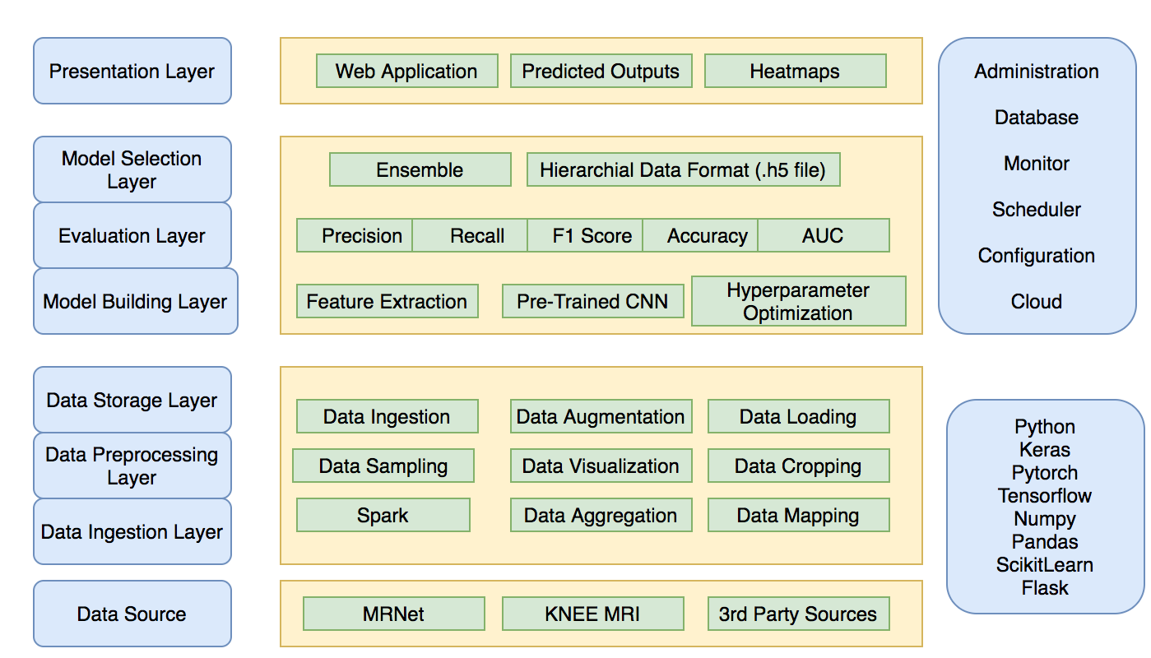

**Figure 1: Conceptual Architecture**

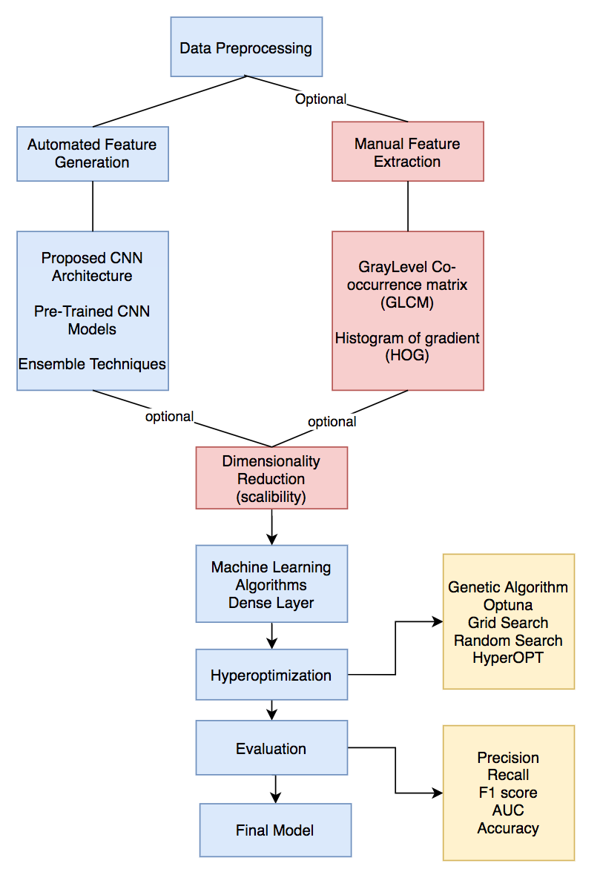

**Figure 2: Flowchart of proposed events for model Building**

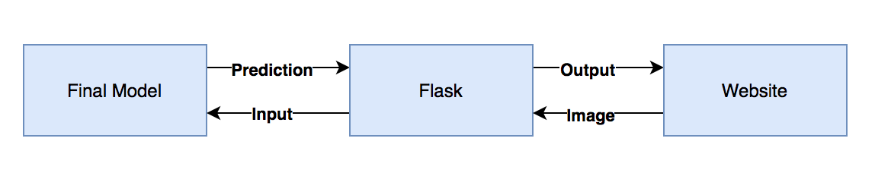

**Figure 3: Flask Pipeline**

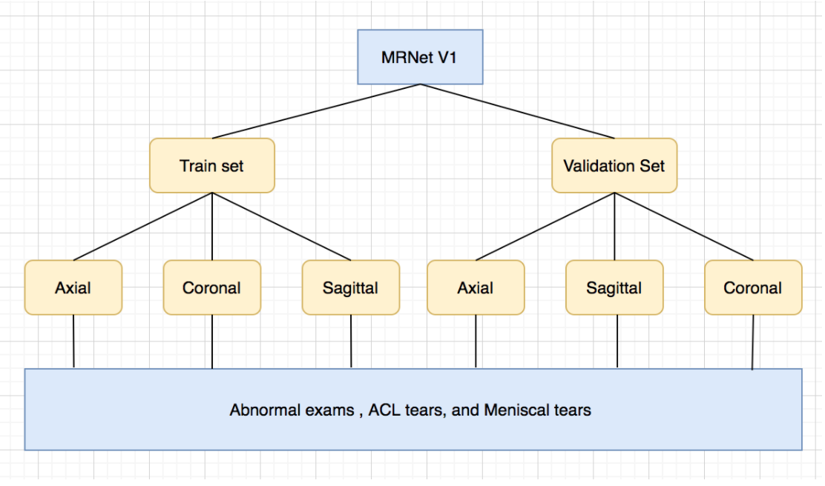

**Figure 4: Distribution of MRNet Dataset**

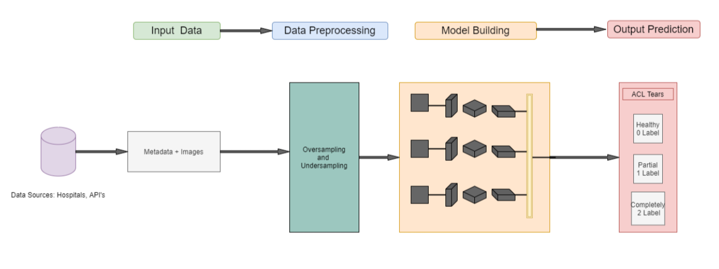

**Figure 5: High Level Design Architecture**

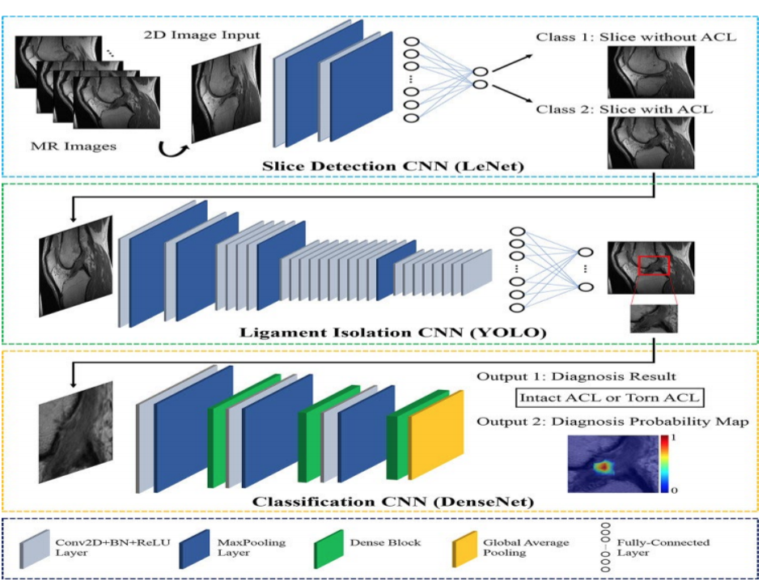

**Figure 6: Proposed deep learning-based ACL tear detection Architecture**

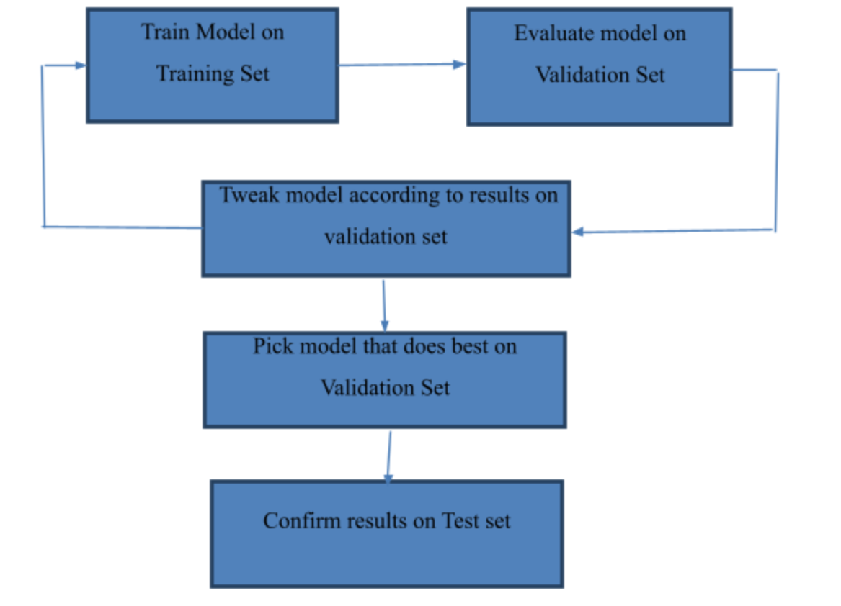

**Figure 7: Model Testing Architecture**

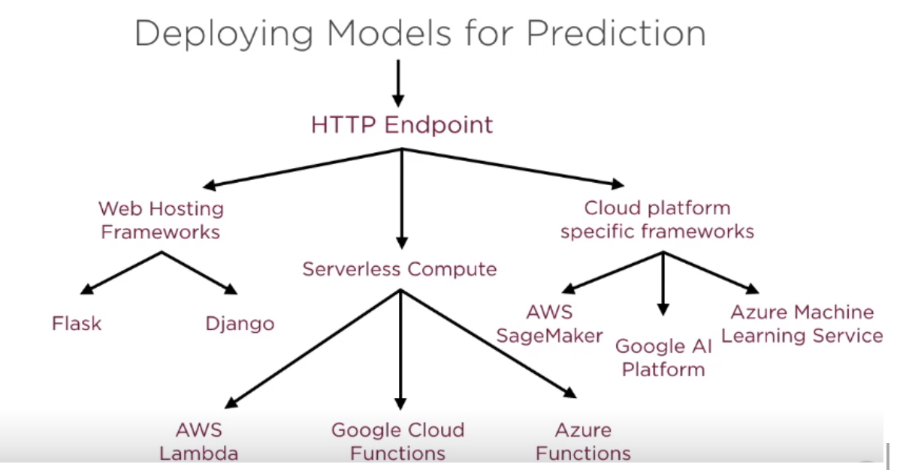

**Figure 8: Deploying Models for prediction**

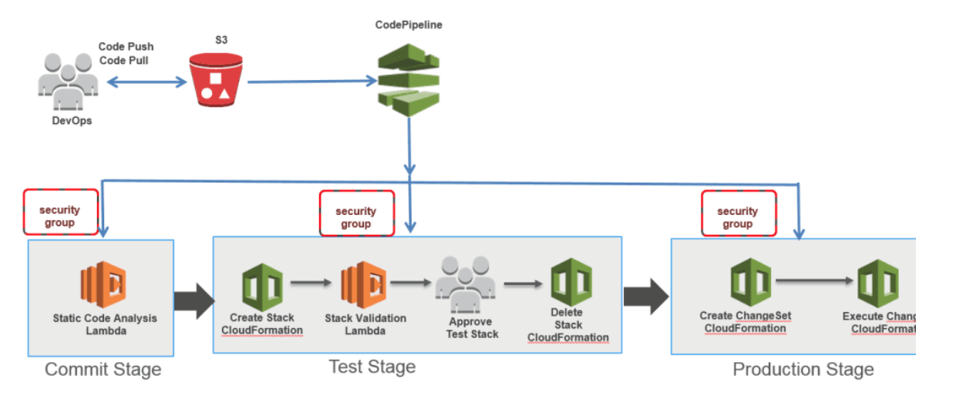

**Figure 9: CI/CD Pipeline**